
Debre Berhan University
College of Computing
Department of Information Technology
Internship Report
Project Title:FieldSync" – Offline-First Reporting And Registration System
Hosting Company: Africom Technologies
Internee: | ID
1. Nebiyat Kenenissa…………… | 1601556
2. Oumer Suhali………………… | 1601
3. Ebrahim Kasaw……………… | 1601116
4. Getiye Demisse………………… | 1601213
5. Hermela Getahun………………. | 1601
Mentor: Kassaye
Company Supervisor: Ananiya Legesse
Africom Technologies
Addis Abeba
September 2026

Declaration
We hereby declare that this internship report entitled “FieldSync: An Offline-First Reporting System” has been prepared as part of the internship requirements of the Department of Information Systems,Information Technology& Computer Science College of Computing, Debre Berhan University.
This report presents the activities, knowledge, skills, experiences, and project work completed during the internship period at AFRICOM Technologies PLC during the 2018 E.C. Academic year. The FieldSync project was developed to address the challenges of collecting, storing, managing, and synchronizing field data in areas where internet connectivity may be limited or unavailable.
We confirm that this report is based on our internship activities, project work, available project documents, and the system development process carried out during the internship. All information and materials obtained from other sources have been appropriately acknowledged and cited. We further declare that the information presented in this report is true and accurate to the best of our knowledge and belief, and we accept responsibility for the originality and academic integrity of the work presented in this report.

Approval
This internship report has been submitted for examination with the approval of the following advisors and examiners.
Advisor’s name:_______________

Signature : _____

Date : _____

Acknowledgements
First and foremost, we would like to express our sincere gratitude to Almighty God for His grace, guidance, strength, and protection throughout our studies and internship period.
we would like to express our sincere appreciation to Debre Berhan University, particularly the Department of Information Systems, Information Technology& Computer science College of Computing, for organizing the internship program and providing us with the opportunity to apply the knowledge and skills we gained through our academic studies in a practical working environment.
We are also deeply grateful to our university internship advisor for the continuous guidance, valuable comments, constructive feedback, and encouragement provided throughout the internship and the preparation of this report.
Our special thanks go to the management and staff of AFRICOM Technologies PLC for welcoming us into the organization, providing a supportive working environment, and giving us the opportunity to gain practical experience in software development. We are especially thankful to our internship mentor and the Software Development Section for their guidance, technical support, feedback, and valuable advice throughout the development of the FieldSync: An Offline-First Field Data Collection and Synchronization System.
We would also like to thank the FieldSync project team members for their cooperation, support, discussions, and contributions throughout the project. Their teamwork and encouragement helped us learn new skills, overcome challenges, and complete the project successfully.
Finally, we would like to express our heartfelt appreciation to our family, and everyone who supported and encouraged us during our studies, internship, and project development. Their moral support and encouragement played an important role in helping us complete this work successfully.
Thank you all for your valuable support and contribution.

Executive Summary
This report presents the details and outcomes of our internship programme undertaken at AFRICOM Technologies PLC in Addis Ababa, Ethiopia, as a partial fulfilment of the degree of Bachelor of Science in Information Technology,Information systems and Computer science offered at Debre Berhan University. The internship was carried out during the 2018 E.C. academic year for a period of approximately three months. During this period, We were attached to the Software Development Section of the company and worked as a junior full-stack developer on the development of FieldSync, an offline-first registration and reporting system designed for government field officers working in rural areas of Ethiopia.
FieldSync was built to solve a real and serious problem. Field officers who register citizens and submit daily field reports often work in places where there is no internet connection. In such environments, paper-based records are easily lost, damaged or delayed, and supervisors receive field data days or weeks after it is collected. FieldSync addresses this by following an offline-first design: data entered on a phone or laptop is saved instantly in a local browser database (Indexed Db using the Dexie library) and is later synchronized automatically to a central server whenever the device reconnects to the internet.
During the internship, our tasks covered the full development life-cycle: requirements gathering and user-role analysis, system design and architecture, database design in PostgreSQL, building the REST application programming interface with Node.js and Express, developing the React and Tailwind CSS front end, implementing the offline synchronization engine, integrating the Global Positioning System for citizen registration, adding support for four Ethiopian languages, and preparing the system for deployment using Docker Compose. The internship significantly improved our practical programming skills, upgraded our theoretical understanding of software engineering concepts such as offline data synchronization, conflict resolution and progressive web applications, and helped us develop our communication, teamwork, leadership, work-ethic and entrepreneurial skills.

TABLE OF CONTENTS
Declaration I
Approval I
Acknowledgements II
Executive Summary III
List of Figures IX
List of Tables X
Chapter One - Background of the Internship Hosting Company 1
1.1 Introduction 1
1.2 Brief History of the Company 1
1.3 Vision and Mission 2
1.4 Main Products and Services 2
1.5 Software Technologies 3
1.6 Hardware and Infrastructure Technologies 4
1.7 Main Customers and End Users 4
1.8 Overall Organisational Structure and Workflow 5
1.9 The Internship Placement and Project Context 7
1.10.Chapter Summary 7
Chapter Two - Overall Internship Experience 8
2.1 How I Joined the Company 8
2.2 Orientation and Onboarding 8
2.3 The Department Where I Worked 8
2.4 Workflow of the Department 9
2.5 Overview of the FieldSync System 9
2.6 Tasks Executed During the Internship 12
2.6.1 Requirements Gathering and Analysis 12
2.6.2 System Design and Architecture 12
2.6.3 User Interface Development with React and Tailwind CSS 12
2.6.4 Offline Data Layer with IndexedDB and Dexie 13
2.6.5 The Synchronisation Engine 13
2.6.6 Backend API Development with Node.js and Express 13
2.6.7 Database Design and SQL 13
2.6.8 Authentication and Role-Based Access 14
2.6.9 Support for Four Ethiopian Languages 14
2.6.10 Reporting, Dashboards and Analytics 14
2.6.11 Additional Operational Modules 14
2.6.12 Testing, Debugging and Bug Fixing 15
2.6.13 Deployment Preparation 15
2.7 Procedures Used While Performing the Tasks 16
2.7.1 Development Environment 16
2.7.2 Version Control Workflow 16
2.7.3 Coding Standards and Quality Checks 16
2.7.4 Testing and Verification Procedure 16
2.8 Our Performance in Carrying Out the Assigned Tasks 17
2.9 Problems Identified During the Internship 17
2.10 Proposed Solutions to the Identified Problems 18
2.11 Theoretical Knowledge 18
2.12 Team Playing Skills 19
2.12 Leadership Skills 20
2.13 Work Ethics, Company Culture and Professional Behaviour 20
Professional Responsibility 20
Confidentiality and Data Privacy 20
Punctuality and Time Management 21
Respect for Organizational Rules 21
Code Review and Accountability 21
Professional Communication 21
Working Under Supervision 22
Adaptation to Company Culture 22
2.14 Interpersonal Communication Skills 22
2.15 Entrepreneurship Skills 23
2.16 Overall Benefits of the Internship 23
2.17 Recommendation and Conclusion on the Internship Place 23
2.17.1 Recommendation 23
2.17.2 Conclusion 24
Chapter Three: Project Work 25
3.1 Summary of the Project 25
3.2 Problem Statement and Justification 26
Problem Statement 26
Justification 27
3.3 Objective of the Project 27
General Objective 27
Specific Objectives 28
Nature of work/ task carried out ........................................................................28
Week 1...........................................................................................................28
Week 2...........................................................................................................29
Week 3...........................................................................................................29
Week 4...........................................................................................................29
Week 5...........................................................................................................29
Week 6...........................................................................................................30
Week 7...........................................................................................................30
Week 8...........................................................................................................30
3.4 Methodology 31
Methodology 31
Fact-Finding Techniques 31
Development Methodology 31
Tools, Languages, and Frameworks 32
3.5 System Requirements and Design 33
3.5.1 User Requirements 33
3.5.2 Functional Requirements 35
3.5.3 Non-Functional Requirements 36
3.5.4 System Constraints 37
3.5.5 Use Case Model 38
3.5.6 Context-Level Data Flow 39
3.5.7 Data Model 39
3.5.8 System Analysis and Modeling 40
3.5.9 Object Modeling 40
3.5.10 Activity Diagrams 41
3.5.11 System and Data Design 42
3.5.12 Class and Object Design 43
3.5.13 Sequence Diagram for Citizen Registration............................................44
3.5.14 Input Validation 44
3.5.15 System Enhancements 44
3.6 Results and Discussion 45
3.7 Screenshots of the Project 46
3.7.1. Home Page 46
3.7.2. Login Page 47
3.7.3. Field Officer Dashboard 47
3.7.4. Registration Form 48
3.7.5.Supervisor Dashboard 48
3.7.6 Manager Dashboard 49
3.8 Conclusion and Recommendation 49
3.8.1 Conclusion 49
3.8.2 Recommendation 50
Chapter Four General Conclusion and Recommendation 53
4.1 General Conclusion 52
4.2 General Recommendation 52
References 54
Appendices 55
Appendix A: Field Sync System Overview 55
Appendix B: System Technologies and Development Tools 55
Appendix C: User Roles and Main Functions 56
Appendix D: Offline Storage and Synchronization 57
Appendix E: Project Screenshots 58
Appendix F: System Testing and Verification 58
Appendix G: Internship Project Activities 59

List of Figures
Figure 1.1: Simplified organizational structure of AFRICOM Technologies PLC 6
Figure 2.1: Field Sync System Architecture 11
Figure 2.3: Offline-first synchronization workflow 11
Figure 3.1: FieldSync Home Page 46
Figure 3.2: FieldSync Login Page 47
Figure 3.3: FieldSync Field Officer Dashboard 47
Figure 3.4: Registration Form 48
Figure 3.5: Supervisor Dashboard 48
Figure 3.6: Manager Dashboard 49

List of Tables
Table 1.1: Software technologies and their main use 3
Table 1.2: Main customers and end-user groups 5
Table 3.1: Tools, languages, and frameworks used for FieldSync 32
Table 3.2: Functional requirements 34
Table 3.3: Non-functional requirements 36
Table A.1: FieldSync system overview 55
Table A.2: System technologies and development tools 55
Table A.3: User roles and main functions 56
Table A.4: Offline storage and synchronization stages 57
Table A.5: Project screenshots 58
Table A.6: System testing and verification areas 58
Table A.7: Internship project activities 59



Chapter One - Background of the Internship Hosting Company

1.1 Introduction
This chapter presents the background of the company that hosted our internship, AFRICOM Technologies PLC. It describes the brief history of the company, its vision and mission, the main products and services it provides, its main customers and end users, and its overall organizational structure and work flow. The chapter also introduces the specific project, FieldSync, on which We worked, because an understanding of the company is essential to understand the environment in which the project was developed.

1.2 Brief History of the Company
AFRICOM Technologies PLC is an Ethiopian information technology solutions and service provider company headquartered in Addis Ababa, in the Goro. The company was founded in 2004 by young Ethiopian entrepreneurs with the aim of bringing effective, affordable and internationally competitive IT solutions to the Ethiopian market. Over the last two decades the company has grown from a small start-up into one of the most recognized IT solution providers in the country, and it is one of the first companies of its kind in Ethiopia to become certified to the ISO 9001:2015 quality management standard. According to the company, its growth is driven by a culture of putting the customer's concerns first and by strategic partnerships with international technology providers. Through these partnerships AFRICOM has been able to concentrate on delivering effective solutions across software development, business process outsourcing, government technology projects and network infrastructure. The company maintains its operations in Addis Ababa and serves clients across Ethiopia and, through its outsourcing services, in other countries in Africa, Asia and Europe. With more than twenty years of continuous operation, AFRICOM has built a reputation as an implementation-focused company that designs solutions and also customizes, deploys and maintains them.

1.3 Vision and Mission
The vision of AFRICOM Technologies PLC is to architect the digital future of Africa through relentless innovation and implementation excellence. The company sees itself as a cornerstone of the African technology ecosystem, and it wants every Ethiopian and African organization to be able to benefit from modern digital services. The mission of the company is to provide innovative, cost-effective and top-quality IT solutions for businesses, government institutions and civil society organizations. It aims to achieve this through custom software development, responsible technology consulting, international-standard implementation practices, and continuous capacity building. The company also places a strong emphasis on ISO-certified processes so that its solutions are delivered in a transparent and reliable manner.

1.4 Main Products and Services
AFRICOM Technologies PLC offers a wide range of information technology products and services. The main product and service lines observed during our stay are summarised below.
- Custom software development: design and development of tailor-made applications for the web, desktop and mobile platforms, using modern technologies such as React, Node.js and PostgreSQL.
- Government technology (GovTech) solutions: building national-scale digital frameworks, including single-window systems, management information systems and logistics systems for government clients.
- Management information system consultancy: advising organizations on how to structure and automate their information flows, collecting, storing and reporting on the data that managers need.
- Business process outsourcing (BPO) and IT outsourcing: providing offshore, nearshore and onshore outsourcing services, back-office support and technical support for clients in Asia, Europe and Africa.
- Enterprise resource planning and e-commerce: integration of finance, human resources and supply chain functions into single systems, and development of online stores with payment and shipping integration.
- Networking, infrastructure and security: planning and installing local area networks, wireless networks and security solutions for offices and institutions.
- IT auditing: evaluating IT infrastructure and policies to determine whether computer systems safeguard assets, maintain data integrity and use resources efficiently.
- Training and capacity building: short courses and the operation of a technology hub for students and professionals.
- Resource augmentation: providing skilled developers, designers and quality-assurance professionals to scale client teams quickly.
From this list it is clear that AFRICOM does not only sell products; it provides complete solutions with custom implementation, customization, training and long-term maintenance services.

1.5 Software Technologies
AFRICOM's public technical information and development-related profiles show the use of modern frontend, backend, database, API, cloud, and DevOps technologies. Angular, React.js, and Node.js are included in the company's relevant web-development technology environment, together with the other technologies listed below. The exact stack can vary according to project requirements.
Table 1.1: Software technologies and their main use
Technology | Main Use
Angular | Frontend development of structured and interactive web applications.
React.js | Development of responsive and reusable web user interfaces.
Node.js | Server-side development and REST API/backend services.
.NET / ASP.NET Core | Enterprise and web application development.
C# | Backend and enterprise application development.
JavaScript | Client-side and full-stack web development.
SQL Server; SQL/NoSQL | Database management and structured or non-structured data storage.
REST APIs | Communication and integration between software systems.
Git | Source-code version control and collaborative development.
Docker; Jenkins/CI/CD | Containerization, automated building, testing, and deployment.
Figma; Adobe XD; Sketch | UI/UX design, wireframing, prototyping, and design-system work.

1.6 Hardware and Infrastructure Technologies
AFRICOM's public materials do not provide a complete inventory of internal hardware brands and models. Therefore, this report describes hardware and infrastructure categories rather than assigning specific brands without company confirmation. These include desktop and laptop computers, servers and cloud infrastructure, network equipment such as routers and switches, data storage systems, mobile devices for application development and testing, and network and security infrastructure. AFRICOM's published project information also demonstrates experience with network infrastructure implementation.

1.7 Main Customers and End Users
The main customers of AFRICOM Technologies PLC are government ministries and agencies, public institutions, private enterprises, small and medium businesses, non-governmental organisations and international clients that outsource software work. Because of the company's history in e-government projects, a large part of its client base is in the public sector.
Table 1.2: Main customers and end-user groups
Customer / End-User Group | Examples of Services or Use
Government institutions | GovTech systems, e-government services, portals, Single Window systems, MIS, and digital transformation.
Private-sector organizations | Software development, e-commerce, enterprise systems, ERP, cloud services, and IT outsourcing.
NGOs and development organizations | ICT consultancy, information systems, software solutions, and project-specific technology services.
Business and technical users | BPO, managed IT support, cybersecurity, technical support, and specialized digital services.

1.8 Overall Organisational Structure and Workflow
AFRICOM Technologies PLC is organized functionally. The general manager, who is also the founder, leads the whole company. Under the general manager, the company is divided into a number of distinct sections and teams, including the Software Development Section, the GovTech and E-Government Section, the BPO and Outsourcing Section, the IT Consulting and Audit Section, the Networking and Security Section, and service lines dealing with e-commerce and enterprise resource planning systems, e-learning, training and the technology hub. Support functions such as finance, human resources and marketing operate across all sections. The company is led by Mr. Baheru Zeyenu, who is identified as Chief Executive Officer on the official company website.
AFRICOM Technologies operates through several major technology and service areas. Based on the publicly available company information, these areas can be represented at a high level as follows:
The organizational structure is illustrated in Figure 1.1 below.
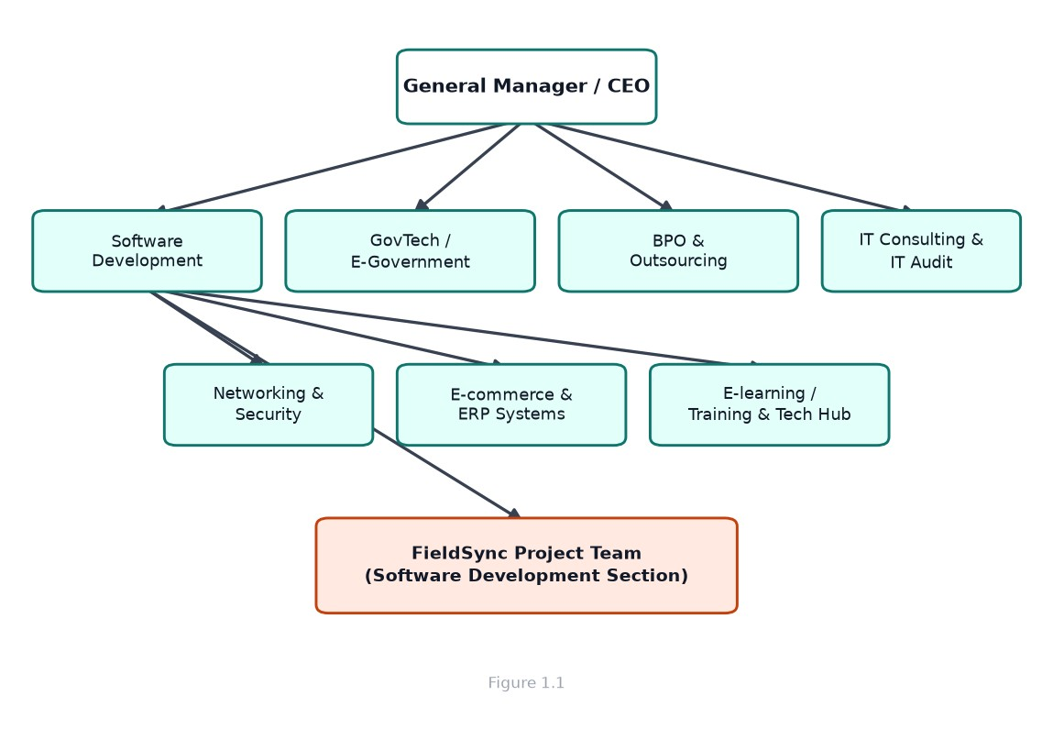
Figure 1.1: Simplified organizational structure of AFRICOM Technologies PLC
The workflow within the company follows a project-based pattern. When a client request is received, the commercial team prepares a proposal and, once the contract is signed, a project team is formed. For software projects the work passes through a typical life cycle consisting of requirements gathering and analysis, system design, development, testing, deployment and maintenance. For medium-size projects the team works in two-week iterations, with daily stand-up meetings and a task board, so that progress is visible to everyone and the client can give feedback continuously. This agile-style workflow was the direct working method used in the Software Development Section during our internship.

1.9 The Internship Placement and Project Context
We were placed in the Software Development Section of the company and assigned to the FieldSync project team. FieldSync is an offline-first registration and reporting system that we will describe in detail in Chapter Two. The project had been initiated because the client, a regional administration, needed a reliable way for field officers in remote villages to register citizens and submit daily reports even though the connectivity in those areas is very poor. Our role in the team was that of a junior developer, working under the guidance of senior developers and our mentor. Working on FieldSync gave us the chance to apply practically almost everything learned in class: web development, databases, software engineering, human-computer interaction and systems analysis. It also gave us the opportunity to work inside a real software team, to observe how a professional Ethiopian IT company organises its work, and to contribute to a system that will improve the way government data is collected in rural areas.

1.10.Chapter Summary
This chapter has described the hosting company. AFRICOM Technologies PLC is an ISO-certified Ethiopian IT solutions company founded in 2004 with more than twenty years of experience in software development, government technology, business process outsourcing and IT consulting. The company follows a functional organisational structure and a project-based workflow, and it serves government and private clients. Our internship was hosted in the Software Development Section where We contributed to the FieldSync project.

Chapter Two - Overall Internship Experience

2.1 How We Joined the Company
The Debre Berhan University Department of Information Technology announces internship placements for final-year students during the second half of the academic year. Interested students submit their applications together with their academic records, and the department shortlists candidates on the basis of their performance in relevant courses such as web programming, databases, data structures and software engineering. We applied through this process and was shortlisted and referred to AFRICOM Technologies PLC. We then went through an interview and a short technical discussion at the company, where we were asked about our knowledge of web technologies, our experience with JavaScript and our interest in developing systems for real users. After the interview we received an offer letter indicating the starting date and the duration of the internship, and we reported to the company on the first working day.

2.2 Orientation and Onboarding
The first week of the internship was dedicated to orientation. We were given a tour of the office, introduced to the employees of the different sections, and given the company's employee handbook, which explains rules regarding working hours, dress code, data confidentiality and internal communications. We also received a desk and the ICT section created accounts for us on the tools used inside the company. During onboarding we visited the FieldSync project repository, read the project documentation and the codebase, and was given a walkthrough of the architecture by a senior developer. We installed the development environment on our machine, which included Node.js, Git, PostgreSQL and Docker, and we successfully ran the application locally by the end of the first week. This early milestone gave us confidence and helped us understand the rest of the work.

2.3 The Department Where We Worked
We worked in the Software Development Section of AFRICOM Technologies PLC. This is the section responsible for designing, building, testing and maintaining the software products of the company. The section is organised into small teams, each focused on one project. We were assigned to the FieldSync team, which at the time consisted of a project lead, two senior developers, a designer and five interns, including myself. The team was responsible for the whole FieldSync system: the web-based progressive web application used by managers and supervisors, the registration and reporting flows used by field officers, the offline storage layer that keeps data on the device, and the backend application programming interface and database that store the final, authoritative version of the data.

2.4 Workflow of the Department
The department followed an agile workflow. Each morning the team held a short stand-up meeting of about fifteen minutes in which every member reported what they had done the previous day, what they planned to do that day, and any blockers. Work was tracked on a task board where each task had a status such as 'to do', 'in progress', 'in review' and 'done'. The development cycle for a typical feature was as follows. First, the requirement was discussed with the project lead and the product owner. Second, the task was broken down and added to the board. Third, a developer created a new branch of the code, implemented the feature, and committed the changes with a clear commit message. Fourth, the branch was merged through a pull request, which was reviewed by another developer. Finally, the merged code was tested by the whole team. Every two weeks the team demonstrated the completed work to senior management. This workflow taught me discipline, code review culture and the importance of clear communication.

2.5 Overview of the FieldSync System
FieldSync is an offline-first registration and reporting system. It is built to support government field officers who move from village to village registering citizens and collecting daily operational reports. Because these officers work in areas with very poor or no internet connectivity, the system is designed so that all data entry works even when the device is completely offline, and data is synchronised when the device regains connection.
The system has three main user roles, each with different screens and permissions:
- Management (manager role): manages users, assign regions, views dashboards, charts and performance statistics, sends alerts to all staff, View supervisor reports and monitors whether officers are online.
- Supervision (supervisor role): follows a group of field officers, verifies daily reports and citizen registrations, view and approve work-permission requests, assigns tasks, evaluates officers on several criteria and compiles supervisor reports.
- Field work (field officer role): registers citizens and completes a daily field report, requests or permission, and answers verification questions.
Technically, FieldSync is a progressive web application built with React and Vite, styled with Tailwind CSS, and made installable and offline-capable through the service worker generated by Vite's PWA plugin. Offline data is stored locally in the browser's IndexedDB using the Dexie library. The backend is a Node.js application built with Express, and the database is PostgreSQL. The system communicates through a JSON REST API, and photo attachments are handled with the Multer library. E-mail notifications such as new account credentials are sent using Nodemailer. The whole system is containerised with Docker. One important quality of the system is that local data and server data are never disconnected for long. When an officer enters data while offline, the record is stored locally with a status of 'pending'. A background sync service watches the network and, as soon as the device is back online, pushes all pending records to the server. The server is designed to accept the same record several times without creating duplicates, using idempotent insert-or-update queries. Figure 2.1 shows the overall three-tier architecture of the system.
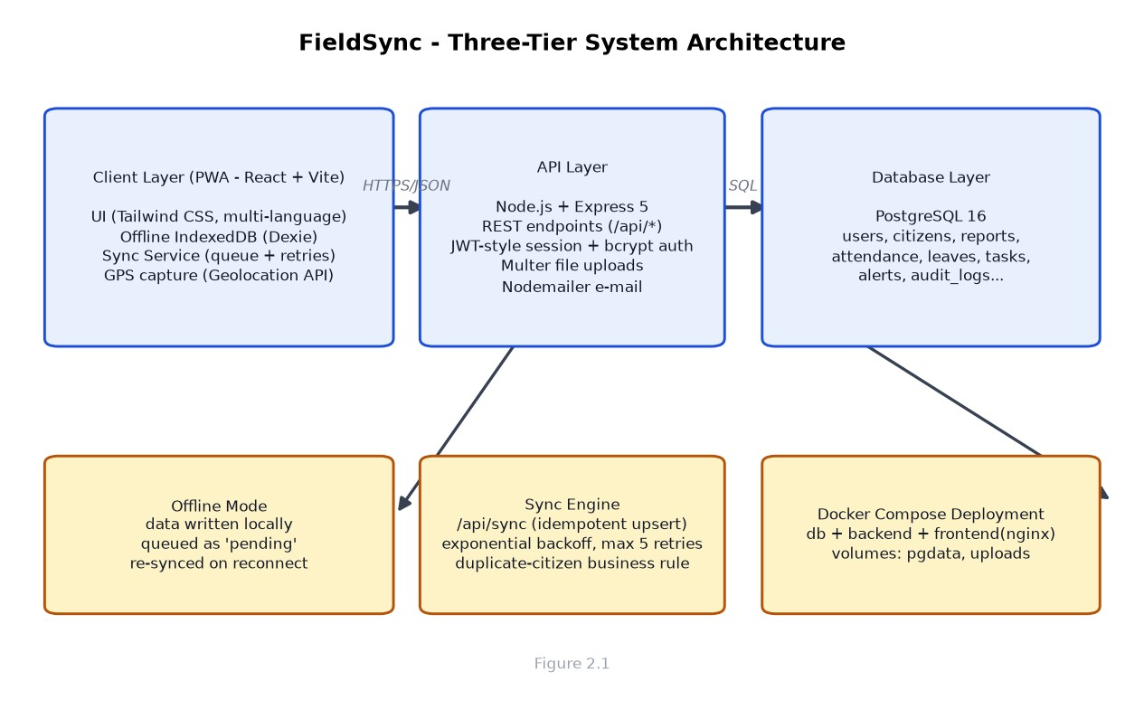
Figure 2.1: Three-tier architecture of the FieldSync system
Figure 2.3 summarises the offline-first synchronisation workflow that was at the heart of the project and that we worked on most closely.
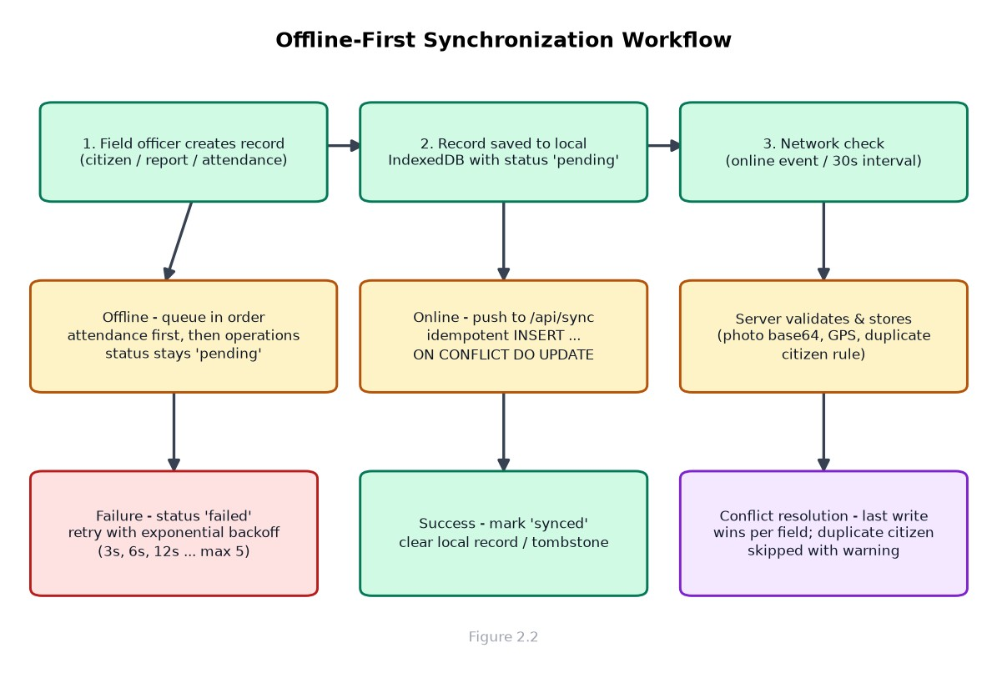
Figure 2.3: Offline-first synchronisation workflow

2.6 Tasks Executed During the Internship
During the internship We executed a wide range of tasks. We describe below the main categories of work We performed, in the order in which they build on one another.

2.6.1 Requirements Gathering and Analysis
At the beginning of the project we were involved in reading the client requirements document and in listening to discussions with the product owner. We learned to distinguish functional requirements (what the system must do) from non-functional requirements (how well it must perform, how secure and reliable it must be). Together with a senior developer, We helped write user stories for the main roles and to list the forms, fields and rules needed for citizen registration, daily reporting and permission requests.

2.6.2 System Design and Architecture
We participated in the design discussions that produced the system architecture shown in Figure 2.1. The key design decisions were to make the application offline-first rather than online-only, to store local data in IndexedDB, to expose a single synchronisation endpoint for all record types, and to use PostgreSQL as the central database. We learned to draw architecture diagrams, to think about the boundaries between layers, and to justify design choices to the team.

2.6.3 User Interface Development with React and Tailwind CSS
A significant part of Our work was building the user interface. We created and modified React components for the login page, the sidebar and header, the dashboard cards and charts, the citizen registration form, the daily report form, and management pages such as user management, team management, permission, task and alert management. We used Tailwind CSS for styling, react-hook-forms and Zod for form input validation, and React Router for navigation. We also used the Recharts library to build the analytics charts on the manager dashboard and handled dark and light themes.

2.6.4 Offline Data Layer with IndexedDB and Dexie
One of the most interesting tasks was building the offline data layer. We wrote the Dexie database schema defining the local tables for users, citizens, reports, permissions, tasks, alerts, screen time, audit records and verification history. Each local table mirrors the server tables and carries an additional 'synced' status field. We also implemented helpers to store and read data locally so that the application continues to work when the server cannot be reached.

2.6.5 The Synchronisation Engine
The synchronisation engine is the brain of the offline-first design. Working from the design already started by the team, we implemented and refined the service that watches the network status, collects all pending records, sends them to the server in the correct order, marks them as synchronised and handles failures. The service uses an exponential backoff so that a failing record is retried after 3 seconds, then 6, then 12, and up to a maximum of five attempts.

2.6.6 Backend API Development with Node.js and Express
We wrote and fixed backend code in the Express API: authentication endpoints for login and password change, and route modules for users, citizens, reports, , leaves, permissions, screen time, alerts, audit logs, verification and supervisor reports. We learned to structure a server into routes, controllers and models, to use parameterised SQL queries to prevent SQL injection, and to return consistent JSON responses to the front end.

2.6.7 Database Design and SQL
The central database is PostgreSQL. We designed and updated tables for the user accounts, citizen records, daily field reports, permissions, messages, screen-time records, verification history, audit logs and supervisor reports. We wrote the SQL queries used by the synchronisation endpoint, including the idempotent insert-or-update statements that use the ON CONFLICT clause, and we helped write the startup scripts that create missing columns and seed the Ethiopian location hierarchy (region, zone, woreda, kebele and community).

2.6.8 Authentication and Role-Based Access
We worked on the authentication module. Passwords are hashed with bcrypt before being stored, so plain-text passwords never appear in the database. New users created by a manager can be sent their account credentials by e-mail automatically.
The application checks the role of the logged in user and shows only the screens relevant to that role, and inactive accounts are blocked at login. We learned the importance of protecting passwords and of always verifying the role of a user before allowing an action.

2.6.9 Support for Four Ethiopian Languages
FieldSync is used by staff whose working languages are different. We helped implement the internationalization (i18n) layer using the i18next library, which allows the interface to switch between English, Amharic, Afaan Oromoo and Tigrinya. We added the translation files and a language selector in the user interface, and we made sure that newly added labels had translations in all four languages. This task taught me how to design software that is truly local, rather than assuming every user reads English.

2.6.10 Reporting, Dashboards and Analytics
We developed the reporting screens: the daily report form used by field officers, the report list and the reports seen by supervisors, and the aggregate reports page for managers. On the dashboard we helped build the statistics grid, the registration and trend charts, the top-performer list and the performance chart. These screens translate raw database records into decisions that managers make every day, and building them improved my understanding of data visualisation and the value of clean, aggregated data.

2.6.11 Additional Operational Modules
Beyond registration and reporting, FieldSync includes a family of smaller modules that together make the system complete. We contributed to most of them:
- work-permission management: officers request leave or permission; supervisors approve or reject, and the decisions synchronize online and offline.
- Alerts and notifications: the manager can broadcast an alert to everyone or to specific users, and users can mark alerts as read.
- Screen-time monitoring: the system tracks how long a user is logged in and calculates a trust score that is shown to supervisors.
- Verification: officers are occasionally asked a verification question; their answers and response times are recorded and scored.
- Audit log: important actions are recorded in an audit log with the user, action, details and timestamp, so that the history of the data can be traced.
- Online status: the server records whether each user is currently online or offline so that supervisors can see who is active.

2.6.12 Testing, Debugging and Bug Fixing
We spent part of the internship testing the system and fixing bugs. We tested the synchronization path by entering records offline, restarting the application, reconnecting and checking that all records reached the server exactly once. We also helped fix a number of real bugs, including a problem in which a profile photo disappeared after synchronization because the front end and the database used different field names, and a bug in which the online/offline status of a user was shown incorrectly. Finding and fixing these bugs taught us how to use the browser developer tools, the network panel and the database console to trace a problem from the screen back to the data.

2.6.13 Deployment Preparation
Towards the end of the internship we helped prepare the system for deployment. We worked with the Docker Compose file that runs three containers: a PostgreSQL database, the Express backend and an nginx web server serving the built front end. We also verified the environment-variable configuration, tested the health endpoint that reports whether the database is reachable, and wrote notes for the person who would deploy the system. This experience introduced us to containerisation, a skill that is rarely taught in class but is essential in the industry.

2.7 Procedures Used While Performing the Tasks

2.7.1 Development Environment
All of the code was developed on a Linux development machine using Visual Studio Code, with Git as the version control system and GitHub as the remote repository. The front end was run with the Vite development server, the backend with a TypeScript execution tool, and PostgreSQL either through Docker or directly on the machine. One useful technique we learned was to read the actual value of the API address from the hostname of the page, so that the application works correctly when it is opened from a phone on the same local network rather than only on localhost.

2.7.2 Version Control Workflow
Every change was tracked in Git. We followed the standard workflow: create a feature branch, make small logical commits with descriptive messages, push the branch, open a pull request, and wait for a review before merging. This procedure protected the main branch from broken code and gave us constant practice in writing commit messages, resolving merge conflicts and reviewing the work of others.

2.7.3 Coding Standards and Quality Checks
The project used a linter (ESLint) and consistent formatting rules. Before finishing a task we ran the linter and fixed all warnings, and We followed the existing naming conventions and file structure of the project.

2.7.4 Testing and Verification Procedure
Before a change was considered complete, we tested it according to a simple but strict procedure. First We tested the happy path (the feature working correctly), then we tested the edge cases (empty input, wrong input, duplicate records), and finally We tested the offline behaviour by turning off the network. Any bug found was logged on the task board or reported to the team lead, and regression tests were run on the previously working features before a release.

2.8 Our Performance in Carrying Out the Assigned Tasks
On the whole, we performed the tasks assigned to us well. Our mentor and the senior developers regularly reviewed the pull requests, and the feedback was generally positive. We were praised especially for the care we took with the synchronisation logic and for the readability of our components. The daily stand-up meetings also helped us to keep the team informed and to ask for help as soon as we was stuck, instead of wasting days on a problem We could not solve. At the same time, we observed areas where we needed to improve. In the beginning we wrote code before fully understanding the existing architecture, which caused us to redo some work. we also found it difficult at first to read large SQL queries and to follow asynchronous JavaScript control flow. With practice We improved in both areas.

2.9 Problems Identified During the Internship
Working on a real system for real users exposed us to problems that are not visible in classroom projects. We identified the following problems during the internship:
- Network instability and sync conflicts: the connection in the field is unreliable, and a record that is edited both on the device and on the server at the same time creates conflicting versions. A clear conflict-resolution policy was needed.
- Large photo attachments: photos taken with a phone are large, and uploading many large photos over a weak connection is slow and sometimes fails.
- No automated test suite: most testing was done manually by the team, which is time-consuming and allows small regressions to slip through.
- Inconsistency between field names: the front end used camelCase field names while the database used snake_case names, and data (for example a profile photo) was lost when the two sides did not agree.
- First-login experience: new users received their passwords by e-mail, but officers without e-mail access could not use the flow, and the forced password change was confusing for some users.
- Amharic text handling: typing and rendering Amharic characters is usually fine, but mixing the languages in one field or copying text between applications sometimes produced inconsistent characters.
- Documentation gaps: the API had no complete, up-to-date documentation, so new team members had to read the code to understand the endpoints.
- Security and data privacy: citizen data is sensitive, and more attention was needed to data privacy, device security and the protection of the server.

2.10 Proposed Solutions to the Identified Problems
For each problem we identified, we proposed a solution. Some proposals were implemented during the internship, while others were recommended for future releases:
- For sync conflicts, adopt a clear rule such as 'last write wins on individual fields' combined with a separate audit of what changed, and record every synchronization in the audit log so that mistakes can be reversed.
- For large photos, compress and resize photos on the device before upload, and upload them separately from the text data with a progress indicator.
- For testing, introduce an automated test framework with unit tests for the validation and synchronization logic and integration tests for the API, and connect it to continuous integration so that every commit is tested.
- For field names, keep the database and the API in agreement by documenting the mapping and by adding a conversion layer in one single place.
- For the first-login experience, allow managers to print or show initial credentials at the point of account creation in addition to e-mail, and support first-login from the same page.
- For Amharic text, use Unicode normalization consistently, test all inputs against the four target languages and avoid manual font assumptions.
- For security, enforce strong passwords, protect the server with a firewall and HTTPS, encrypt backup copies of the citizen data and restrict export rights to senior managers only.

2.11 Theoretical Knowledge
The internship at AFRICOM Technologies PLC helped us strengthen and understand the theoretical knowledge We had gained from our university courses by applying it to a real software development project. Working on the FieldSync system allowed us to see how concepts learned in the classroom are applied when developing software for actual users and real operational environments.
- Software engineering principles
- Database management
- Web programming
- Client-server architecture
- REST APIs
- Authentication and authorization
- Software testing
- System architecture
- Distributed/offline-first concepts
- Data synchronization
- Information security
- Human-computer interaction
- Data visualization
For example, we learned that database and software engineering concepts studied in class become more complex when they must support real users, unreliable networks, synchronization, and sensitive citizen data.

2.12 Team Playing Skills
we learned how to communicate with other team members, share ideas, ask for help when facing technical problems, and accept feedback from senior developers.
- Daily stand-up meetings
- Working with senior developers
- Code review
- Pull requests
- Asking for technical assistance
- Giving and receiving feedback
- Resolving merge conflicts
- Sharing responsibility
- Coordinating tasks
- Working toward a common project goal

2.12 Leadership Skills
we also learned to take initiative when facing problems, identify possible solutions, and discuss them with senior developers and the project team. Participating in task discussions, code reviews, and daily stand-up meetings helped us become more confident in presenting.
- Managing your own tasks
- Reporting progress
- Identifying problems early
- Suggesting technical solutions
- Helping with debugging
- Meeting deadlines
- Accepting feedback
- Making decisions within your assigned responsibility

2.13 Work Ethics, Company Culture and Professional Behaviour
During our internship at AFRICOM Technologies PLC, we gained a better understanding of professional work ethics, workplace behavior, company culture, and our responsibilities in a professional software development environment.

Professional Responsibility
- We learned to take responsibility for the tasks assigned to us.
- We learned to complete our work carefully and within the expected time.
- We understood the importance of being accountable for the quality of our work.
- We learned to report problems and mistakes honestly.

Confidentiality and Data Privacy
- We learned the importance of keeping company and project information confidential.
- We understood that citizen information handled by FieldSync is sensitive and must be protected.
- We learned to handle user and system data responsibly.
- We were introduced to company rules concerning data confidentiality during orientation.

Punctuality and Time Management
- We learned the importance of arriving at work on time.
- We learned to organize tasks according to their priority and deadlines.
- Daily stand-up meetings helped us report our progress and plan our daily activities.
- We understood that good time management helps the team complete tasks effectively.

Respect for Organizational Rules
- We learned to follow the company's rules, procedures, and working practices.
- We respected working hours and professional workplace behavior.
- We understood that following organizational rules helps create a productive working environment.

Code Review and Accountability
- We learned that software development requires our work to be reviewed by other developers.
- Through pull requests and code reviews, we learned to accept feedback and correct mistakes.
- We became more responsible for the quality and reliability of the code we contributed.

Professional Communication
- We learned how to communicate respectfully with project leaders, senior developers, and other team members.
- We improved our ability to explain technical problems clearly.
- We learned to ask for assistance when necessary and provide regular progress updates.

Working Under Supervision
- We learned how to work under the guidance of senior developers and project leaders.
- We received feedback and used it to improve our work.
- We learned to follow technical instructions while taking responsibility for our assigned tasks.

Adaptation to Company Culture
- We learned how to adapt to a professional software development environment.
- We became familiar with teamwork, task tracking, code review, and development procedures.
- We learned to respect different ideas and working styles.
- We understood that successful software development requires cooperation, discipline, communication, and commitment to common goals.
Overall, we learned that professional work requires more than technical knowledge. It also requires responsibility, discipline, confidentiality, punctuality, respect, communication, teamwork, accountability, and the ability to adapt to a professional working environment.

2.14 Interpersonal Communication Skills
- Communicating with the project lead
- Communicating with senior developers
- Participating in stand-up meetings
- Explaining technical problems
- Asking questions professionally
- Receiving constructive criticism
- Giving progress updates
- Discussing requirements
- Presenting completed work
- Communicating during code review

2.15 Entrepreneurship Skills
- Understanding real customer problems
- Developing solutions based on user needs
- Thinking about software as a product
- Understanding the importance of reliability
- Considering cost and resource limitations
- Identifying opportunities for improving existing systems
- Understanding the importance of customer satisfaction
- Thinking about maintainability and scalability
- Understanding how technology can solve problems in organizations

2.16 Overall Benefits of the Internship
We can summarize our development in five major areas:
- Technical development – React, backend development, PostgreSQL, IndexedDB, APIs, synchronization and Docker.
- Software engineering experience – requirements, architecture, Git, code review, testing and deployment.
- Professional development – teamwork, communication, responsibility and workplace discipline.
- Problem-solving ability – identifying real-world problems and developing practical solutions.
- Career preparation – understanding how software development is performed in a professional organization.

2.17 Recommendation and Conclusion on the Internship Place

2.17.1 Recommendation
Our internship experience at AFRICOM Technologies PLC provided us with an opportunity to apply our academic knowledge in a practical software development environment. Through our involvement in real software development activities, collaborative development, code review, database development, testing, and deployment, we gained a better understanding of the differences between classroom-based programming and professional software development.
For future internship students, we recommend that the internship program should continue to provide:
- Practical involvement in real software development projects.
- Regular mentoring and technical guidance from experienced developers.
- Opportunities to participate in team meetings, discussions, and code reviews.
- Exposure to modern development tools, frameworks, and professional software development practices.
- Opportunities to work on different stages of the software development process, including requirements analysis, implementation, testing, and deployment.
These opportunities can help students strengthen their technical knowledge, teamwork, communication, problem-solving, and professional skills.

2.17.2 Conclusion
Overall, the internship was an important part of our academic and professional development. Through our work in the Software Development Section, we gained practical experience in developing and maintaining a real-world software system. We participated in requirements analysis, system design, frontend and backend development, database management, offline storage, synchronization, GPS integration, testing, debugging, and deployment preparation.
The internship also helped us improve our teamwork, communication, leadership, professional ethics, problem-solving, and entrepreneurship skills. More importantly, it allowed us to understand how theoretical concepts learned at university are applied when developing software for real users and real operational conditions.

Chapter Three: Project Work
Project Title: FieldSync: An Offline-First Field Data Collection and Synchronization System
Part Four presents the project we worked on during our internship at AFRICOM Technologies PLC. It describes the project background, the problem identified in the existing system, the objectives, development methodology, technologies and tools used, system design, results, screenshots, conclusion, and recommendations.

3.1 Summary of the Project
FieldSync is an offline-first field data collection and synchronization system developed to support field personnel who work in areas where internet connectivity may be weak, unstable, or unavailable.
The system is designed for three main user roles: Manager, Supervisor, and Field Officer. Field Officers use the system to collect registration information and submit operational reports. Supervisors monitor field activities and review information from assigned areas, while Managers manage users, areas, projects, and overall system activities.
A major feature of FieldSync is its ability to continue working when there is no internet connection. Field data can be temporarily stored in the browser using IndexedDB. When the internet connection becomes available again, the stored records can be synchronized with the central server and PostgreSQL database.
The project uses technologies including React, Vite, TypeScript, Tailwind CSS, Node.js, Express.js, PostgreSQL, IndexedDB/Dexie, REST API, Git/GitHub, and Docker.
The system also includes features related to:
- Citizen/registration data collection
- Offline data storage
- Data synchronization
- Ethiopian geographic location hierarchy
- Daily reporting
- Notifications and alerts
- User authentication and role-based access
- Performance monitoring
- Dashboards and reports
Through this project, we applied theoretical knowledge from our university studies to a practical software development environment and gained experience in requirements analysis, system design, frontend and backend development, database management, testing, debugging, teamwork, and software development practices.

3.2 Problem Statement and Justification

Problem Statement
The existing field data collection and reporting process faces several challenges, particularly when field personnel work in areas with poor or unreliable internet connectivity. Field Officers may need to collect registration information and prepare reports while working in remote areas where continuous access to the internet cannot be guaranteed.
The main problems identified in the existing system include:
- Dependence on internet connectivity: Field activities can be affected when the internet connection is weak or unavailable.
- Difficulty collecting data offline: Field Officers may not be able to reliably submit registration information when they are working without network access.
- Delayed data synchronization: Information collected in the field may not reach the central system immediately when connectivity is unavailable.
- Data consistency problems: Synchronizing records after working offline can create conflicts or inconsistent information if it is not properly managed.
- Difficulty monitoring field activities: Supervisors and Managers may have limited visibility into field progress and operational activities.
- Reporting challenges: Delays in receiving field reports can make it difficult to monitor daily activities and performance.
- Large file handling: Photos and other attachments can make data transfer and synchronization more difficult.
- Security and privacy concerns: Registration information needs to be handled carefully because it may contain sensitive citizen information.
These challenges were also identified during the development of FieldSync. The project documentation specifically identifies network instability, synchronization conflicts, duplicate citizen registrations, large photos, testing limitations, security and data privacy, and timestamp issues as important challenges.

Justification
The FieldSync project was proposed to address these problems by providing an offline-first field data collection and synchronization system.
The main justification for developing FieldSync is that Field Officers should be able to continue their work even when internet connectivity is unavailable. The system uses IndexedDB/Dexie for local storage, allowing records to remain available on the user's device until they can be synchronized with the central server.
The proposed system provides the following improvements:
- Allows Field Officers to collect and store data offline.
- Synchronizes locally stored records when network connectivity is restored.
- Provides role-based access for Managers, Supervisors, and Field Officers.
- Provides reports and dashboards for monitoring field operations. .
- Improves centralized management of registration and operational data.
- Provides mechanisms for handling synchronization failures and retrying unsuccessful synchronization attempts.
Therefore, FieldSync is justified as a practical solution for improving the reliability of field data collection and reporting, particularly in environments where network connectivity cannot always be guaranteed. The project also gives us an opportunity to apply software engineering, database, web development, security, and system design knowledge to a real-world problem.

3.3 Objective of the Project

General Objective
The general objective of the FieldSync project is to develop an offline-first field data collection and synchronization system that enables field personnel to collect, store, manage, and synchronize registration and operational data reliably, even in areas with limited or unreliable internet connectivity.

Specific Objectives
The specific objectives of the project are to:
- Develop a responsive web-based system for field data collection and reporting.
- Enable Field Officers to collect registration data during field activities.
- Allow Field Officers to continue working when the internet connection is unavailable.
- Store offline records securely using IndexedDB.
- Synchronize locally stored records with the central server when network connectivity is restored.
- Provide role-based access for Managers, Supervisors, and Field Officers.
- Provide daily reports and operational information.
- Provide dashboards for monitoring field activities and performance.
- Improve the management and monitoring of field registration activities.
- Maintain data consistency and reduce the risk of data loss during synchronization.
- Apply appropriate security, authentication, and access-control mechanisms to protect system data.
These objectives are consistent with the project features and development activities documented in our internship report, including offline storage, synchronization, reporting, role-based access, and monitoring.
Nature of work/ task carried out
1. Week one
Abstract
During the first week of our internship, we focused on project planning and the preparation of comprehensive documentation for the Field-sync First Offline Registration System Management System. The documentation process involved gathering and analyzing system requirements, identifying key functionalities,
and preparing structured reports to guide the upcoming design and development phases.
2. Week Two
Abstract
During the second week of our internship, the main focus was on updating and refining the project documentation for the Field-sync First Offline Registration System Management System. based on feedback received from the supervisor. In addition, we worked on setting up the computer environment and configuring the necessary software tools required for development. Toward the end of the
3week, We also began the initial coding phase, implementing a few basic components of the system to test the setup and functionality.
3. Week Three
Abstract
During the third week of our internship, the focus shifted from documentation to system development, particularly the design and implementation of the user interface for the Field-sync First Offline Registration System Management System. This phase involved developing key front-end pages such as the login page, home page, and other related user interfaces. The goal was to create an interactive and user-friendly environment that aligns with the system requirements defined earlier.
4. Week four
Abstract
During the fourth week of our internship, the focus was on updating the user interface based on feedback received from the supervisor and continuing the development of Manager pages for the Field-sync First Offline Registration System Management System. Key pages developed included the Manager login page, dashboard, and other related modules. The objective was to create a functional, user-friendly interface for Manager while ensuring consistency and integration with existing supervisor and field officer interfaces.
5. Week Five
Abstract
During the fifth week of our internship, we are going to do the three role dashboard that are related with each other and have some figure about our project and by consult our company advisor we updated the style of user interface according to our company advisor instruction and also we will have meeting and describe our ideas to do the user interface of formal project.
6. Week Six
Abstract
During the sixth week of our internship, the focus shifted toward developing the System offline storage .so in this week we install the PWA(Progressive Web App ) to our working area and then we create offline storage database by using indexdb in our browser .

7.Week Seven
Abstract
During the seventh week of our internship, We start the central database using Postgress SQL and then check the end API endpoints by using Postman and we fix bugs that are related to the local database (index db ) and our central database (postgress).we were checked all functionality and integration of our user interface and database so we push our project in github then we prepared to our presentation.
8.Week Eight
Abstract
The final week of our internship was dedicated to the official project handover and final evaluation by the organization. In this week we all presented our project to our company supervisor and he gave as a good comment to us .

3.4 Methodology

Methodology
The methodology used for the FieldSync project describes how we identified the system requirements, selected development technologies, designed the system, and implemented and tested the proposed solution.

Fact-Finding Techniques
We used the following techniques to understand the existing field data collection process and identify the requirements of the proposed system:
Interview: We discussed system requirements and operational problems with relevant project members and supervisors to understand the needs of field data collection and reporting.
Observation: We considered field working conditions, especially the challenges faced by Field Officers when working in areas with poor or unavailable internet connectivity.
Document Review: We reviewed project requirements, system documentation, and existing development materials to understand the required functions and system processes.
Team Discussion: We participated in requirement discussions and project meetings to clarify requirements, assign tasks, and discuss possible solutions. The development process included daily standups, task discussions, code reviews, and project demonstrations.

Development Methodology
We followed an Agile development approach. The project was developed incrementally through requirement analysis, planning, implementation, testing, review, and improvement.
The main activities were:
Requirement Analysis →Planning →System Design →Development →Testing → Code Review →Improvement →Deployment
The team used feature branches, commits, pull requests, code reviews, testing, staging, and demonstrations as part of the development process

Tools, Languages, and Frameworks
The main technologies used for developing FieldSync were:
Table 3.1: Tools, languages, and frameworks used for FieldSync
Category | Technology | Purpose
Frontend | React | Developing the user interface
Build Tool | Vite | Frontend development and building
Programming Language | TypeScript | Developing frontend and backend features
Styling | Tailwind CSS | Designing the responsive interface
Backend | Node.js | Server-side application runtime
Framework | Express.js | Developing REST APIs
Database | PostgreSQL | Central data storage
Offline Storage | IndexedDB / Dexie | Storing data locally when offline
API | REST API | Communication between client and server
Version Control | Git / GitHub | Managing source code and collaboration
Containerization | Docker | Supporting development and deployment
Internationalization | i18next | Supporting multiple languages

3.5 System Requirements and Design
The Field-sync system requirements and design describe the requirements, constraints, models, and technical structure of the proposed system. Field-sync is an offline-first Progressive Web Application designed for public-sector field operations and demographic data collection in Ethiopia. The system uses React, TypeScript, Vite, and Tailwind CSS for the client application; Dexie.js with IndexedDB for local offline storage; Node.js and Express.js for the backend REST API; and PostgreSQL as the central database.
The system is designed around three main user roles: Field Officer, Regional Supervisor, and System Manager. Each role has different responsibilities and access to system functions.

3.5.1 User Requirements
User requirements describe what the different users expect from the FieldSync system.
Field Officer Requirements
- Log in securely using email and password.
- Change the password during the first login.
- Register citizens and capture demographic information..
- Enter date of birth, gender, telephone number, and administrative location..
- Search and view citizen records.
- Work when there is no internet connection.
- Submit daily work reports.
- View previously submitted reports and supervisor feedback.
- Submit leave and permission requests.
- Respond to random presence and security verification challenges.
Supervisor Requirements
- Monitor assigned Field Officers.
- View officer work status and accumulated screen time.
- Review verification events.
- Review submitted daily work reports.
- Create and assign operational tasks.
- Monitor task progress.
- Communicate with Field Officers and Managers.
Manager Requirements
- View organization-wide performance information.
- Monitor citizen registration statistics.
- Monitor Field Officer performance.
- Manage user accounts.
- Assign users to administrative areas.
- Assign Field Officers to Supervisors.
- Reassign Field Officers.
- Monitor leave and permission information.
- View security audit logs.
- Monitor system operations and data synchronization.

3.5.2 Functional Requirements
Functional requirements describe the functions that the FieldSync system shall provide.
Table 3.2: Functional requirements
ID | Description | Priority
FR-01 | The system authenticate users using email and password. | High
FR-02 | The system support Field Officer, Supervisor, and Manager roles. | High
FR-03 | The system start counting of the Field Officer working time automatically when the Field Officer login to the system. | High
FR-04 | The system automatically track active Field Officer screen time. | High
FR-05 | The system automatically pause screen-time tracking when the application is not actively being used. | High
FR-06 | The system provide random presence and security verification challenges. | High
FR-07 | The system allow Field Officers to register citizens. | High
FR-08 | The system capture citizen demographic and identification information. | High
FR-09 | The system validate citizen information, including Ethiopian telephone numbers. | High
FR-10 | The system check for duplicate citizen registrations by there phone number. | High
FR-11 | The system allow citizen photographs and documents to be attached to registration records. | High
FR-12 | The system store field data locally when the device is offline. | High
FR-13 | The system synchronize pending records with the central server when connectivity becomes available. | High
FR-14 | The system allow Field Officers to prepare and submit daily work reports. | High
FR-15 | The system allow Field Officers to view their report history and supervisor feedback. | Medium
FR-16 | The system allow Field Officers to submit leave and permission requests. | Medium
FR-17 | The system l allow Supervisors to monitor assigned Field Officers. | High
FR-18 | The system allow Supervisors to see daily reports. | High
FR-29 | The system allow Supervisors to provide feedback on submitted reports. | High
FR-20 | The system allow Supervisors to monitor and manage leave and permission requests. | High
FR-21 | The system allow Supervisors to create and assign operational tasks. | Medium
FR-22 | The system allow Managers to create and manage user accounts. | High
FR-23 | The system allow Managers to assign users to administrative areas and Supervisors. | High
FR-24 | The system provide organization-wide dashboards and performance analytics. | High
FR-25 | The system l maintain activity and security audit logs. | High
FR-26 | The system provide notifications and alerts. | Medium
FR-27 | The system support English, Amharic, Afaan Oromoo, and Tigrinya. | Medium
FR-28 | The system display online, offline, and synchronization status. | High
FR-29 | The system allow authorized users to see synchronization status . | Medium
FR-30 | The system provide light and dark themes. | Low
FR-31 | The system provide Progressive Web Application functionality and offline application access. | High
Note: The High, Medium, and Low values are project priority classifications.

3.5.3 Non-Functional Requirements
Table 3.3: Non-functional requirements
Category | Requirement
Performance | The system provide responsive data entry and processing during field operations.
Availability | The system remain usable when internet connectivity is unavailable through its offline storage capability.
Reliability | The synchronization process maintain reliable transfer of offline records without duplicate database records or data collisions.
Security | The system protect user and operational information using authentication, authorization, password hashing, JWT authorization, and parameterized database queries.
Usability | The system provide a clear interface appropriate for Field Officers, Supervisors, and Managers.
Offline Operation | The system allow data to be collected and stored locally without an internet connection.
Data Integrity | The system maintain consistent data between local IndexedDB storage and the central PostgreSQL database.
Maintainability | The system use a structured technology stack that supports maintenance and future development.
Scalability | The system support multiple users, administrative areas, field activities, and increasing amounts of collected data.
Portability | The PWA should be installable and usable on Android, iOS, Windows, and macOS devices.
Localization | The system support English, Amharic, Afaan Oromoo, and Tigrinya.
Auditability | Important system activities recorded in activity and security audit logs.
Usability in Different Environments | The system provide light and dark themes suitable for different working and lighting conditions.
Extensibility | The system allow additional operational functions to be added in future versions.

3.5.4 System Constraints
Internet Connectivity Constraint: Field Officers may work in locations where internet connectivity is weak or unavailable. Therefore, the system must support local storage and later synchronization.
Device and Browser Constraint: The offline functionality depends on browser capabilities such as IndexedDB and the Progressive Web Application environment.
Security Constraint: The system handles citizen and workforce information. Therefore, access must be restricted to authorized users and system operations must be protected.
Role-Based Access Constraint: Field Officers, Supervisors, and Managers have different responsibilities. The system must ensure that users only access functions appropriate to their roles.
Synchronization Constraint: Offline records must eventually reach the central database without creating duplicate records or data conflicts.
Operational Constraint: Field Officers operate within defined work-session and monitoring rules, including working-hour controls, screen-time tracking, and verification challenges.

3.5.5 Use Case Model
The Use Case Model describes the interactions between FieldSync users and the system. The main actors are Field Officer, Supervisor, and Manager.
Field Officer use cases include login, citizen registration, viewing records, submitting daily reports, leave and permission requests, verification responses, and viewing personal work history.
Supervisor use cases include monitoring Field Officers, reviewing verification events, reviewing and viewing reports, providing feedback, monitoring , managing leave and permissions, assigning tasks, and communicating with field staff.
Manager use cases include viewing organization-wide dashboards, managing users, assigning and reassigning personnel, monitoring leave and permissions, viewing audit information, and monitoring performance.

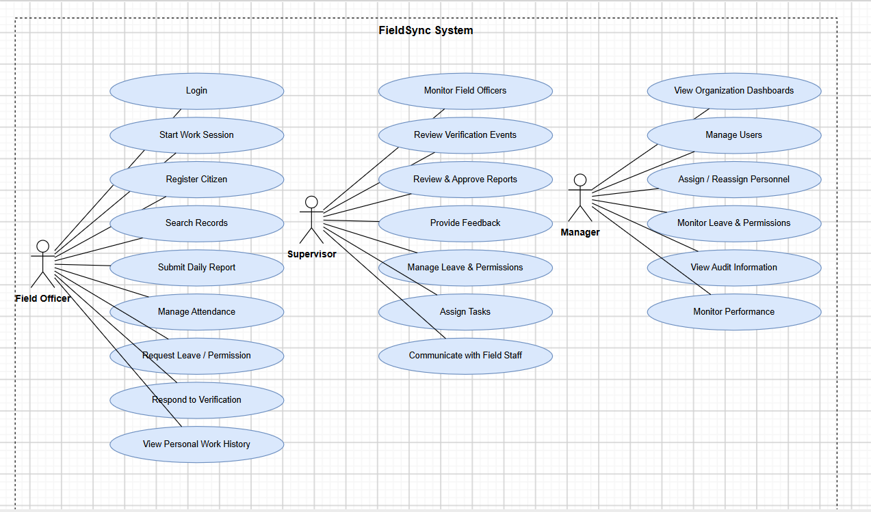

3.5.6 Context-Level Data Flow
The context-level data flow shows FieldSync as the central system interacting with its major users and data storage components.
The Field Officer provides citizen registration information and daily reports. The Supervisor receives submitted reports, reviews field activities, provides feedback, manages requests, and assigns tasks. The Manager manages users, administrative assignments, organizational monitoring, and performance information.
FieldSync exchanges information with local IndexedDB storage and the central PostgreSQL database through the synchronization process.
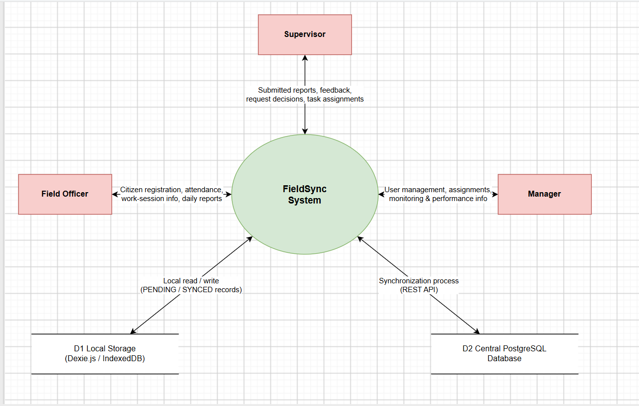
Figure 3.1: Context-Level Data Flow Diagram

3.5.7 Data Model
FieldSync uses a combination of local and central data storage. The client uses Dexie.js with IndexedDB, while the central server uses PostgreSQL. This provides a mirrored data architecture that allows users to continue working offline and synchronize information when connectivity becomes available.
The major entities include Users, Citizens, Work Sessions, Daily Screen Times, Work Verifications, Daily Work Reports, Supervisor Reports, , Tasks, Leaves, Permissions, Activity Logs, Audit Logs, Alerts and Notifications, and administrative hierarchy data.
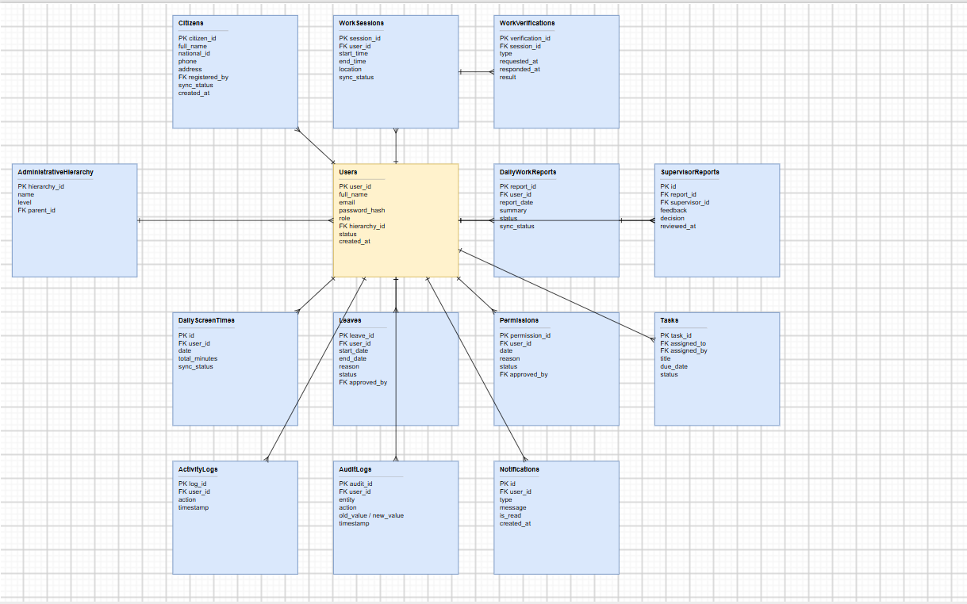

3.5.8 System Analysis and Modeling
System analysis identifies the major processes that FieldSync must support and the relationships between users, data, and system functions.
The main processes are user authentication, citizen registration, local offline data storage, screen-time monitoring, presence and security verification, daily work-report preparation, Supervisor review and approval, leave and permission management, synchronization with the central server, and managerial monitoring and analytics.

3.5.9 Object Modeling
Object modeling identifies the major objects used by the FieldSync system and their associated information.
The main objects include User, Citizen Registration, Daily Screen Time, Work Verification, Daily Work Report, Supervisor Report, Task, Leave, Permission, Activity Log, Audit Log, Alert/Notification, and Administrative Hierarchy.

3.5.10 Activity Diagrams
Activity diagrams describe the sequence of activities performed during important FieldSync operations.
Citizen Registration Activity: Start → Field Officer Login → Start Screen time by the system→ Open Citizen Registration → Enter Citizen Information → Validate Information → Check for Duplicate → Save Registration → Check Internet Availability → Store Locally as PENDING or Synchronize with Server → Registration Completed.
Synchronization Activity: Create or Update Record → Save to IndexedDB → Set Status to PENDING → Detect Internet Connection → Send Record to Backend → PostgreSQL Processing → Successful synchronization → Mark as SYNCED; if unsuccessful, keep the record PENDING.
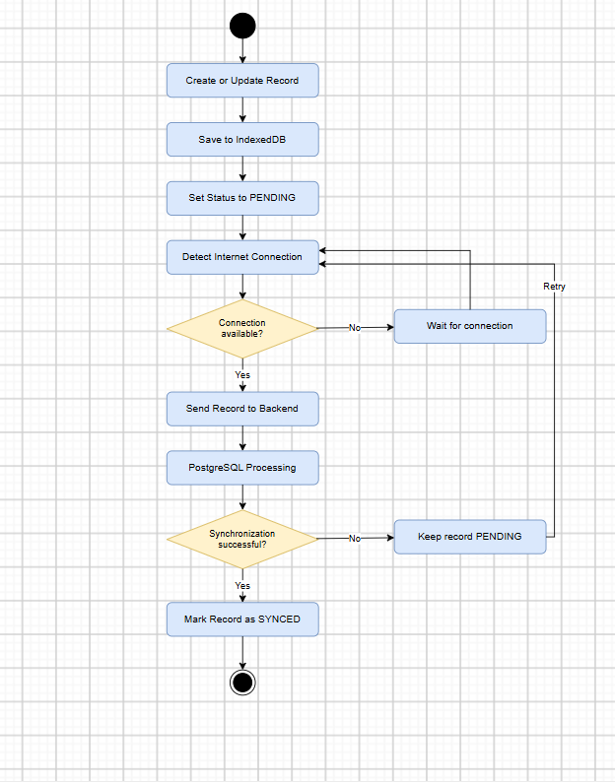

3.5.11 System and Data Design
FieldSync follows a client-server architecture with an offline local data layer.
The client application uses React, TypeScript, Vite, and Tailwind CSS. The local data layer uses Dexie.js and IndexedDB with service-worker-based offline application support. The backend uses Node.js, Express.js, REST API, CORS, and JWT authorization. PostgreSQL provides the central relational database.
The overall data flow is: FieldSync Client → React/TypeScript → Dexie.js/IndexedDB → Synchronization Engine → Node.js/Express REST API → PostgreSQL Database.
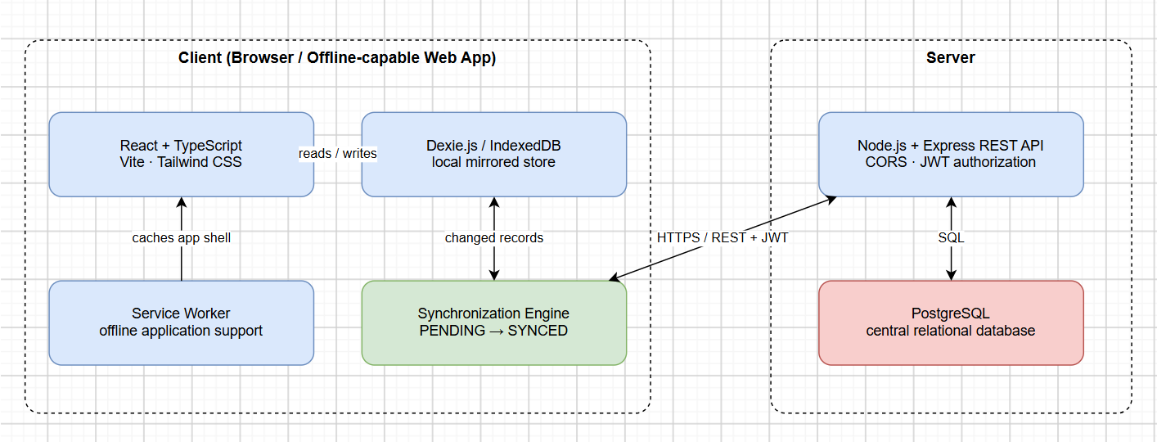

3.5.12 Class and Object Design
The class and object design organizes system entities according to their responsibilities and relationships.
The User class represents Field Officers, Supervisors, and Managers. The Citizen class represents citizens registered by Field Officers. Other classes represent daily screen time, verification events, reports , leave and permissions request, activity logs, audit logs, and notifications.
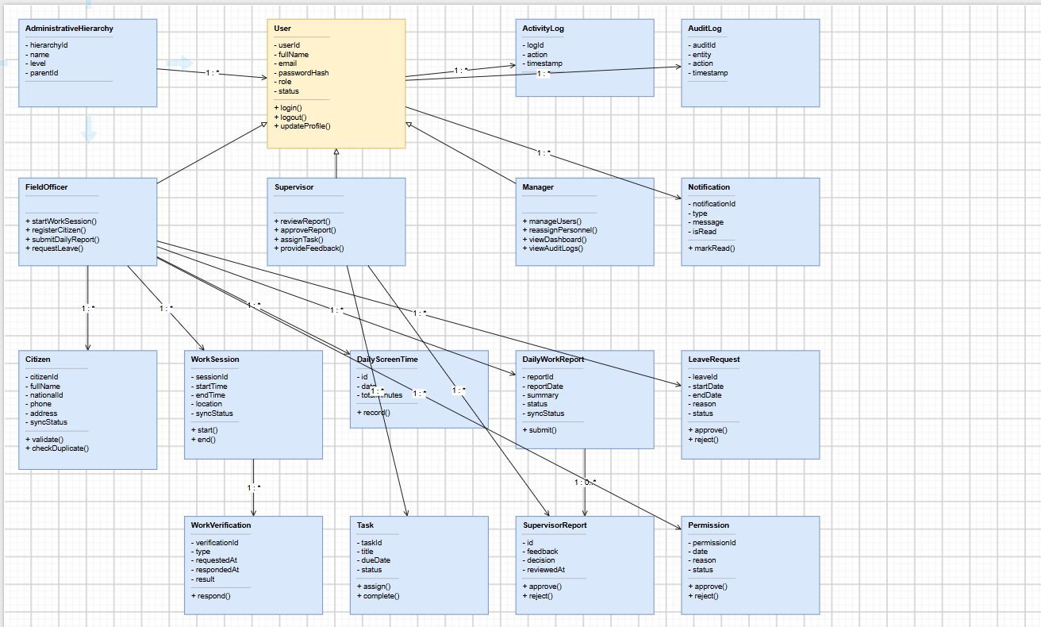

3.5.13 Sequence Diagram for Citizen Registration
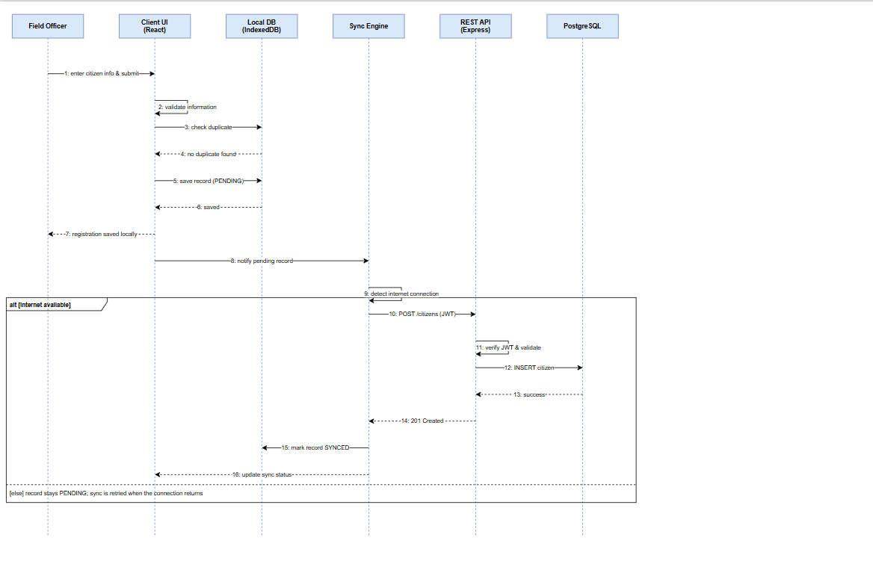

3.5.14 Input Validation
Input validation ensures that information entered into the system follows the required format and business rules.
FieldSync performs validation for required citizen information, National ID or Kebele identification information, date of birth, gender, Ethiopian telephone numbers, administrative location, user account information, work reports, leave requests, permission requests, and verification responses.
The system specifically validates Ethiopian telephone numbers using accepted formats such as +251-9..., ., 09...etc

3.5.15 System Enhancements
The FieldSync system includes enhancements designed to improve field operations, reliability, monitoring, and usability.
Major enhancements include offline-first data collection, automatic two-way synchronization, duplicate prevention through idempotent database operations, automatic screen-time tracking, random presence and security verification, four-language localization, light and dark themes, notifications and alerts, Progressive Web Application capabilities, organization-wide dashboards, security audit logs, manual Force Sync functionality, and cross-platform installation and use.
The synchronization engine detects connectivity, stores offline changes locally with a PENDING status, and sends queued records to the backend when connectivity returns. Idempotent PostgreSQL operations reduce duplicate records and data collisions.

3.6 Results and Discussion
The implementation of the proposed system resulted in a functional solution that addresses the major problems identified in the existing field data collection and reporting process. The developed system provides a structured way for field officers to enter registration information, store records locally when an internet connection is unavailable, and synchronize collected data when connectivity becomes available.
The results show that the system improves the organization and management of field data by reducing dependence on manual recording and providing a centralized approach to data management. Validation mechanisms help reduce incomplete or invalid records, while controlled user access ensures that users can perform activities according to their assigned responsibilities.
Another important result is the support for offline data collection. Field officers can continue working in areas where network connectivity is limited or temporarily unavailable. Collected information can be stored locally and synchronized with the central system when a connection is restored. This approach is particularly useful for field operations where reliable internet access cannot always be guaranteed.
The system also provides monitoring and reporting capabilities. Supervisors and managers can use collected information to monitor field activities, review submitted records, and understand operational progress. This can improve decision-making because information is available in a more organized and timely manner.
From the discussion of the results, the system demonstrates that combining responsive web technologies, local storage, database management, authentication, validation, and synchronization mechanisms can provide a practical solution for field-based data collection. However, system performance and synchronization effectiveness depend on factors such as device capability, network availability, data volume, and the quality of implementation.
Overall, the results indicate that the proposed system provides a more organized, reliable, and efficient approach to field data collection and reporting compared with a process that depends mainly on manual or continuously connected data entry.

3.7 Screenshots of the Project
This section presents screenshots of the developed Offline FieldSync System. The screenshots demonstrate the main interfaces and functionalities implemented during the project development and show how different users interact with the system.

3.7.1. Home Page
The home page provides the main entry point to the Offline FieldSync System. It introduces the system and provides access to the login interface.
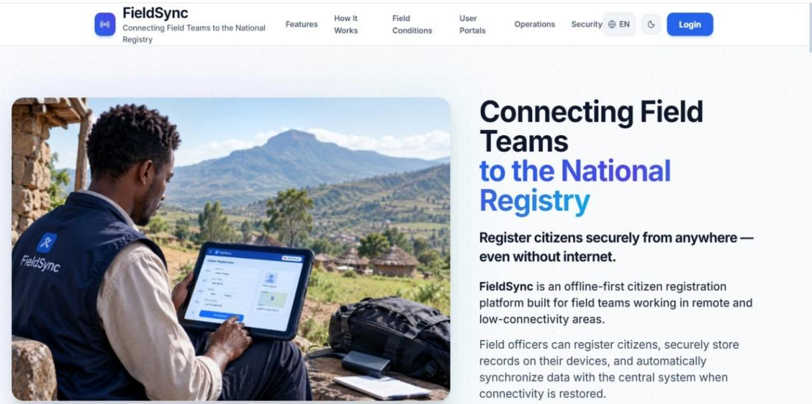
Figure 3.1: FieldSync Home Page

3.7.2. Login Page
The login page allows authorized users to access the system using their registered credentials. It provides fields for email and password and supports secure user authentication.
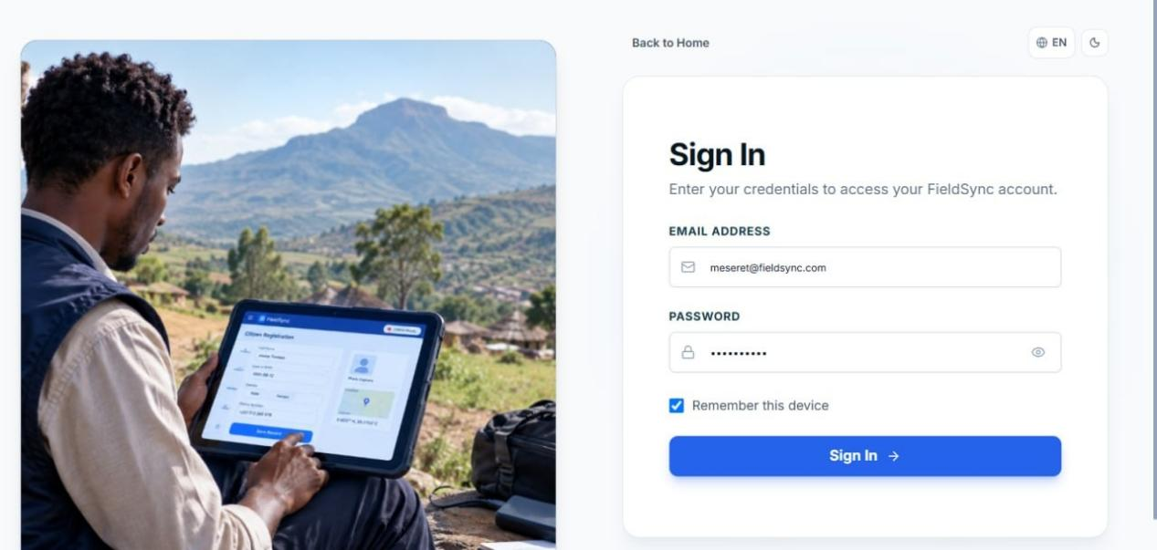
Figure 3.2: FieldSync Login Page

3.7.3. Field Officer Dashboard
The Field Officer Dashboard provides field personnel with access to the functions required for their daily activities. It provides navigation to registration, bottleneck reporting, and personal reports.
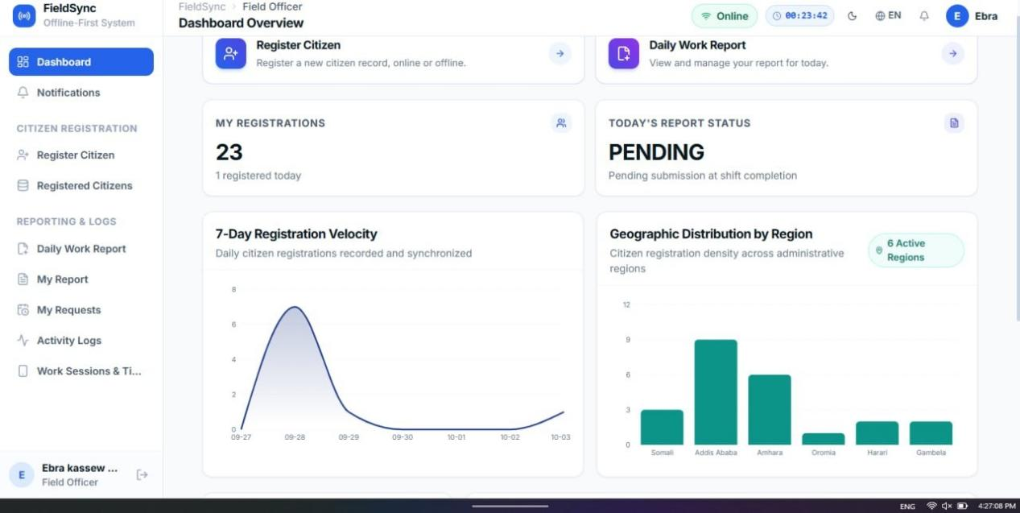
Figure 3.3: Field Officer Dashboard

3.7.4. Registration Form
The registration form is used by field officers to enter Citizen registration information. The form includes validation mechanisms to reduce incomplete or incorrect data entry.
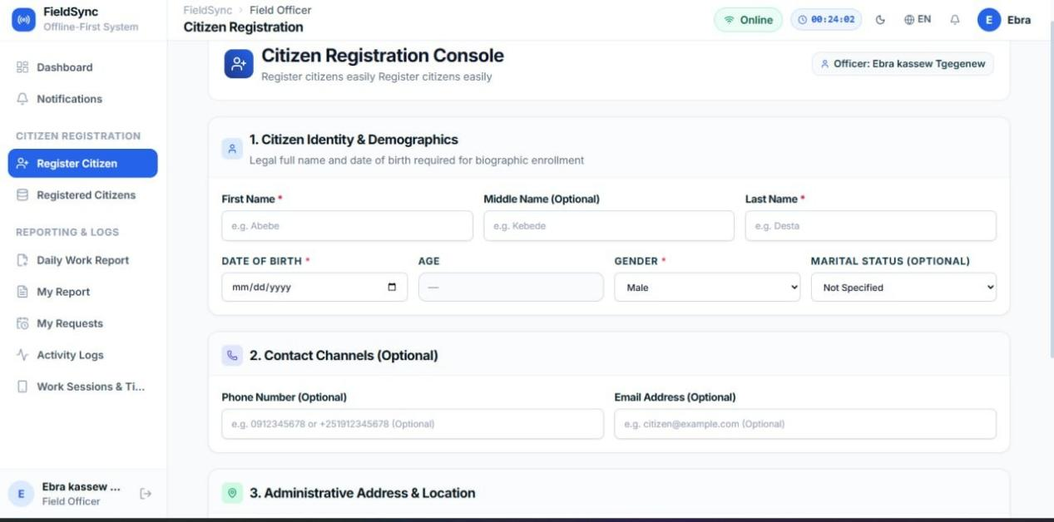
Figure 3.4: Registration Form

3.7.5.Supervisor Dashboard
The Supervisor Dashboard provides supervisors with information about assigned field officers, collected records, progress, and reported operational issues.
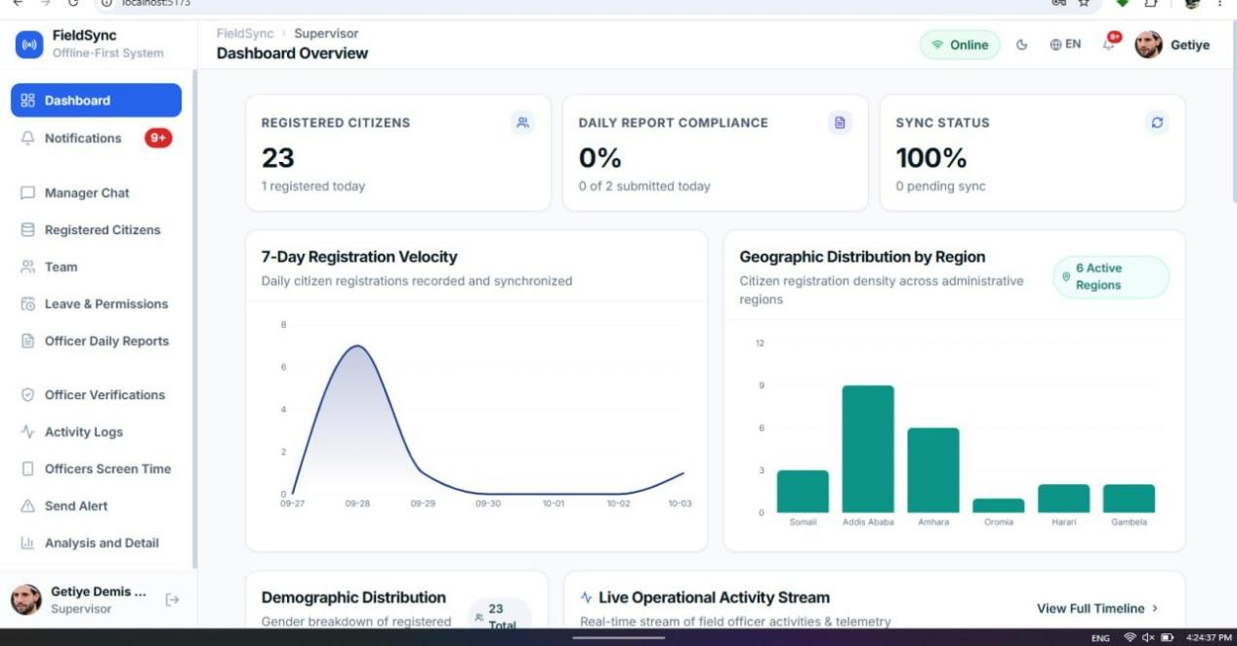
Figure 3.5:Supervisor Dashboard

3.7.6 Manager Dashboard
The Manager Dashboard provides an overview of field operations and supports monitoring of users, registration activities, synchronization, and reports.
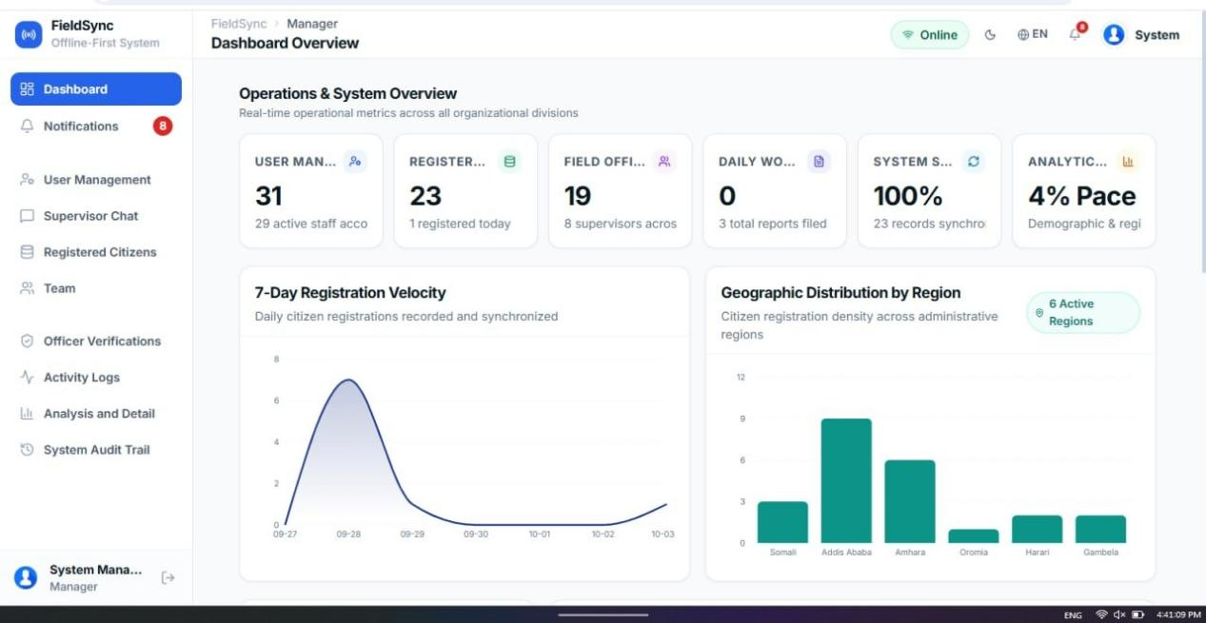
Figure 3.6: Manager Dashboard

3.8 Conclusion and Recommendation

3.8.1 Conclusion
The Offline FieldSync System was developed to address the challenges associated with field-based data collection and reporting, particularly in areas where internet connectivity is limited or unavailable. The system provides a structured platform for field officers to collect registration information, store data locally, and synchronize the collected records with the central system when network connectivity becomes available.
The system also provides important functions such as data validation, duplicate detection, role-based access control, community-based assignment, monitoring, and reporting. These functions help improve the organization and management of field data and support supervisors and managers in monitoring field activities.
One of the main outcomes of the project is the integration of offline functionality into the field data collection process. By using local storage, field officers can continue collecting information without depending continuously on an internet connection. Once connectivity is restored, the collected information can be synchronized with the central database.
Overall, the project demonstrates how a responsive web-based, offline-first system can support field data collection and reporting in environments with unreliable network connectivity. The system provides a foundation that can be further improved and extended according to future operational requirements.

3.8.2 Recommendation
Based on the development and evaluation of the Offline FieldSync System, the following recommendations are proposed:
- Improve synchronization: The synchronization mechanism should be continuously tested and improved to ensure reliable data transfer, especially when large amounts of offline data are submitted at the same time.
- Strengthen data security: Authentication, authorization, encryption, secure API communication, and regular database backups should be maintained to protect collected registration information.
- Improve offline storage management: Local storage should be monitored carefully to prevent data loss when devices have limited storage capacity or are damaged.
- Conduct further usability testing: Field officers, supervisors, and managers should participate in additional usability testing to identify interface difficulties and improve the overall user experience.
- Provide user training: Users should receive appropriate training on registration, offline data collection, synchronization, reporting, and handling synchronization errors.
- Improve monitoring and reporting: Future versions can provide additional dashboards, analytical reports, and export options to help managers and supervisors understand field activities more effectively.
- Support future expansion: The system architecture should remain flexible so that additional regions, communities, users, forms, and reporting requirements can be incorporated without major changes to the existing system.
In conclusion, continued testing, user feedback, security improvements, and enhancement of the synchronization and reporting features can help make the Offline FieldSync System more reliable and suitable for practical field operations.

Chapter Four General Conclusion and Recommendation

4.1 General Conclusion
The internship provided an opportunity to apply the knowledge and skills gained from university studies to a practical software development environment. During the internship at AfriCom Technologies, the team gained practical experience in system analysis, requirements gathering, system design, database management, web application development, testing, documentation, teamwork, and problem solving.
The main project, Offline FieldSync System, was developed to support field-based data collection and reporting, particularly in situations where reliable internet connectivity cannot always be guaranteed. The system provides a structured environment for field officers to collect registration information, store data locally when offline, and synchronize the collected records when connectivity becomes available. It also supports role-based access, data validation, community-based assignment, monitoring, and reporting.
Overall, the internship successfully connected academic learning with practical software development experience and provided valuable knowledge about developing information systems for real-world organizational requirements.

4.2 General Recommendation
Based on the overall internship experience and the development of the Offline FieldSync System, the following recommendations are provided:
- For Africom Technologies: The company should continue providing students with practical opportunities to participate in real software development projects so that they can strengthen their technical and professional skills.
- For future development: The Offline FieldSync System should be continuously improved based on feedback from actual users and field requirements.
- For system security: Appropriate security measures should be maintained to protect user accounts and collected registration data.
- For system maintenance: Regular maintenance, testing, and updating should be conducted to keep the system reliable and functional.
- For users: Adequate training should be provided to field officers, supervisors, and managers before the system is used in actual field operations.
- For future interns: Students should actively participate in practical tasks, ask questions, document their activities, and apply the theoretical knowledge they learned at university.
- For the university: The university should continue strengthening cooperation with organizations such as Africom Technologies so that students can gain practical experience related to their field of study.

References
AFRICOM Technologies PLC. (2024). About Us. AFRICOM Technologies. Retrieved from https://africom.et/about
AFRICOM Technologies PLC. (2024). GovTech Solutions. AFRICOM Technologies. Retrieved from https://africom.et/services/govtech-solutions
AFRICOM Technologies PLC. (2024). BPO Services. AFRICOM Technologies. Retrieved from https://africom.et/services/bpo
AFRICOM Technologies PLC. (2024). E-commerce Solutions. AFRICOM Technologies. Retrieved from https://africom.et/services/ecommerce-solutions
Dexie.js. (2024). Dexie.js - A Minimalistic Wrapper for IndexedDB. Retrieved from https://dexie.org
Duckett, J. (2014). JavaScript and JQuery: Interactive Front-End Web Development. Wiley.
Express.js. (2024). Express - Node.js web application framework. Retrieved from https://expressjs.com
Mozilla Developer Network. (2024). IndexedDB API. MDN Web Docs. Retrieved from https://developer.mozilla.org/en-US/docs/Web/API/IndexedDB_API
Mozilla Developer Network. (2024). Progressive web apps. MDN Web Docs. Retrieved from https://developer.mozilla.org/en-US/docs/Web/Progressive_web_apps
Node.js. (2024). Node.js Documentation. Retrieved from https://nodejs.org/en/docs
PostgreSQL. (2024). PostgreSQL Documentation. Retrieved from https://www.postgresql.org/docs
React. (2024). React Documentation. Retrieved from https://react.dev
Recharts. (2024). Recharts - a composable charting library built on React components. Retrieved from https://recharts.org
Silver, H. (2023). Tailwind CSS documentation. Retrieved from https://tailwindcss.com/docs
Vite. (2024). Vite - Next Generation Frontend Tooling. Retrieved from https://vitejs.dev

Appendices FieldSync: An Offline-First Reporting and Registeration system

Appendix A: Field Sync System Overview
Table A.1: FieldSync system overview
Item | Description
Project Title | FieldSync: An Offline-First Reporting and Registeration system
Hosting Organization | AFRICOM Technologies PLC
Main Purpose | Supports field personnel in collecting registration and operational data where internet connectivity is weak, unstable, or unavailable.
User Roles | Manager, Supervisor, and Field Officer
Core Principle | Offline-first operation with local storage and later synchronization to the central server.
Central Database | PostgreSQL
Local Storage | IndexedDB with Dexie
Interface | Responsive web-based client

Appendix B: System Technologies and Development Tools
Table A.2: System technologies and development tools
Category | Technology | Purpose
Frontend | React | Developing the user interface
Build Tool | Vite | Frontend development and building
Language | TypeScript | Frontend and backend development
Styling | Tailwind CSS | Responsive interface design
Backend | Node.js | Server-side runtime
Framework | Express.js | REST API development
Database | PostgreSQL | Central data storage
Offline Storage | IndexedDB / Dexie | Local storage when offline
API | REST API | Client-server communication
Version Control | Git / GitHub | Source-code management and collaboration
Containerization | Docker | Development and deployment support
Internationalization | i18next | Multiple-language support

Appendix C: User Roles and Main Functions
Table A.3: User roles and main functions
User Role | Main Functions
Manager | Manages users, areas, projects, system activities, registration activities, synchronization, and reports.
Supervisor | Monitors assigned field officers, reviews collected records, follows progress, and monitors operational issues.
Field Officer | Collects citizen registration information, submits operational/bottleneck reports, and continues field work during offline periods.

Appendix D: Offline Storage and Synchronization

Table A.4: Offline storage and synchronization stages
Stage | System Operation
1. Data Entry | Field Officer enters registration or operational information through the responsive web interface.
2. Offline Storage | When connectivity is unavailable, records are stored locally in IndexedDB using Dexie.
3. Pending Records | Locally stored records remain available for later synchronization.
4. Connectivity Restored | The system attempts to synchronize stored records with the central server.
5. Server Storage | Successfully synchronized records are stored in the central PostgreSQL database.
6. Failure Handling | Synchronization failures can be retried to improve reliability.

Appendix E: Project Screenshots…..

Table A.5: Project screenshots
Figure | Interface | Purpose
Figure 3.1 | FieldSync Home Page | Main entry point and access to login.
Figure 3.2 | FieldSync Login Page | Allows authorized users to authenticate.
Figure 3.3 | Field Officer Dashboard | Provides access to daily field activities, registration, bottleneck reporting, and personal reports.
Figure 3.4 | Registration Form | Used to enter citizen registration information with validation.
Figure 3.5 | Supervisor Dashboard | Shows assigned field officers, collected records, progress, and operational issues.
Figure 3.6 | Manager Dashboard | Provides an overview of users, registration activities, synchronization, and reports.

Appendix F: System Testing and Verification
Table A.6: System testing and verification areas
Test Area | Verification Focus
Offline Data Entry | Verify that Field Officers can enter data when internet connectivity is unavailable.
Local Persistence | Verify that offline records remain available after application restart.
Synchronization | Verify that locally stored records synchronize when connectivity returns.
Duplicate Prevention | Verify that duplicate citizen registrations are detected or reduced according to implemented rules.
Validation | Verify that incomplete or invalid registration information is identified.
Role-Based Access | Verify that users access functions according to their responsibilities.
Reporting | Verify that collected information can be reviewed through dashboards and reports.

Appendix G: Internship Project Activities
Table A.7: Internship project activities
Activity | Main Work Performed
Requirements Analysis | Identified field data collection problems and analyzed requirements.
System Design | Contributed to architecture, workflows, data structures, and interface planning.
Frontend Development | Developed responsive interfaces using React, Vite, TypeScript, and Tailwind CSS.
Offline Data Layer | Worked with IndexedDB/Dexie for local browser storage.
Synchronization | Worked on synchronization of locally stored records with the central server.
Backend Development | Worked with REST API functionality using Node.js and Express.js.
Database Work | Worked with PostgreSQL data structures and SQL-related tasks.
Authentication | Worked with authentication and role-based access.
Multilingual Support | Supported English, Amharic, Afaan Oromoo, and Tigrinya.
Testing and Debugging | Tested offline operation, synchronization, validation, and corrected implementation issues.
Deployment Preparation | Prepared environment configuration and Docker-based deployment support.

